# 

**DEPARTMENT OF INFORMATION SCIENCE AND ENGINEERING**

**A MINI PROJECT REPORT ON**

**“Digital Data Reader”**

*Submitted in the partial fulfillment of the requirements in the 4th semester of*

**BACHELOR OF ENGINEERING**

**IN**

**INFORMATION SCIENCE AND ENGINEERING**

**FOR**

**COURSE NAME: MINI PROJECT**

**COURSE CODE: 20ISE391A**

By

**Hrithik U– 1NH20IS063**

**K L Tejas – 1NH20IS068**

***Under the guidance of***

**Dr. S. Senthamarai Kannan**

Professor



**CERTIFICATE**

Certified that the project work entitled “Digital Data Reader” carried out by Mr. Hrithik U, bearing USN 1NH20IS063 and Mr. K L Tejas, bearing USN 1NH20IS068, a bonafide student of IV semester in partial fulfillment for the award of Bachelor of Engineering in Information Science & Engineering of New Horizon College of Engineering, an autonomous institute affiliated to the Visvesvaraya Technological University, Belagavi during the year 2021-22. It is certified that all corrections / suggestions indicated for Internal Assessment have been incorporated. The project report has been approved as it satisfies the academic requirements in respect of Mini Project work prescribed for the said Degree.

**Name & Signature of Guide Name & Signature of HOD**

Dr. S. Senthamarai Kannan Dr. Mohan H S

**Examiners :**

**Name Signature**

1. …………………………………………………. ………………………………..
2. …………………………………………………… …………………………………

**ACKNOWLEDGEMENT**

Any project is a task of great enormity and it cannot be accomplished by an individual without support and guidance. I am grateful to a number of individuals whose professional guidance and encouragement has made this project completion a reality.

We have a great pleasure in expressing our deep sense of gratitude to the beloved Chairman **Dr. Mohan Manghnani** for having provided us with a great infrastructure and well-furnished labs.

We take this opportunity to express our profound gratitude to the Principal **Dr.Manjunatha** for his constant support and management.

We are grateful to **Dr. Mohan H S**, Professor and Head of Department of ISE, New Horizon College of Engineering, Bengaluru for her strong enforcement on perfection and quality during the course of our mini project work.

We would like to express our thanks to the guide Dr. S. Senthamarai Kannan, Professor, Department of ISE, New Horizon College of Engineering, Bengaluru who has always guided us in detailed technical aspects throughout our mini project.

We would like to mention special thanks to all the Teaching and Non-Teaching staff members of Information Science and Engineering Department, New Horizon College of Engineering, Bengaluru for their invaluable support and guidance.

**Hrithik U– 1NH20IS063**

**K L Tejas – 1NH20IS068**

**TABLE OF CONTENTS**

CHAPTER 1**………………………………………………………………………………….…** 1-7

Introduction

1.1 Motivation of the Project 1-6

1.2 Problem Statement 7

1.3 Problem Definition 7

CHAPTER 2 **…………………………………………………………………...……………….** 8-9

Literature Survey

2.1 Existing System 8

2.2 Proposed System 8

2.3 Objectives of the Proposed System 9

CHAPTER 3**……………………………………………………………………………………...** 10

System Requirement Specifications

3.1 Hardware Requirements 10

3.2 Software Requirements 10

CHAPTER 4**………………………………………………………………………………….** 11-15

System Design

4.1 Architectural Design 11

4.2 Algorithm/Flowchart 12-15

CHAPTER 5**………………………………………………………………………………….** 16-25

Implementation

5.1 Code implementation 16-25

CHAPTER 6**………………………………………………………………………………….** 26-27

Results 26-27

CHAPTER 7**……………………………………………………………………………………...** 28

Conclusion & Future Enhancement 28

Reference**………………………………………………………………………………………...** 30

**LIST OF FIGURES**

|  |  |  |
| --- | --- | --- |
| **Figure No.** | **Figure Name** | **Page No.** |
| **4.1** | **Block diagram** | **11** |
| **4.2** | **Flowchart** | **12-14** |
| **6.1** | **Output Page** | **26-27** |

**Abstract**

Now a days the world is moving towards the digital side.

Many prefer to keep data in the digital format.

What is digital data?

Digital data-data stored by computers in the form of 0s and 1s usually in HDD or SSD

Why digital data is preferred?

* Portable
* easy to edit
* data cannot be lost easily
* read write of data is fast
* digital data can be duplicated easily
* they are quite secure in terms of privacy

Schools, College, Hospitals etc use digital data. This digital data is usually in the form of pdf's, excel sheets, video, audio etc. there is no single application which can run all of these formats of digital data. Usually, two or more softwares are required.

Our idea is to create a software which can run almost any digital data format.We would be able to view and modify the digital data. The software would be able to convert from one format to another format as well.

# CHAPTER 1

# **INTRODUCTION**

## Introduction

# We have used python programming language for this project. As we all know Python is an interpreted high-level programming language, used in

# most industrial applications. Its design mainly emphasizes code readability with its use of indentation. Its object-oriented approach is a boon to programmers to assist them write lucid, logical code for every kinds of projects.

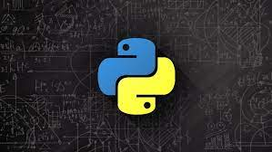

# Python is essentially a language that’s typed dynamically and also garbage collected. It also supports multiple programming types which include structured or procedure oriented programming, functional programming, and object oriented programming. It may be called as a beginner’s language as in it’s easy to learn, read and write (because of its simple English like syntax) for some body who is starting his/her coding journey and also has extensive open-source libraries which are meant for a selected purpose like data science and analysis, machine learning, cyber security, artificial intelligence, web development, etc.

# The language is kind of flexible and productivity friendly and successively, has a very supportive community of developers because the language is open source and also its easily extensible with other languages like C/ C++/ JAVA etc.

# **So Why Python?**

# Some python features include:

# a) Open source:

# Python is free and open source, available to everyone. The massive community support towards making and publishing new modules and functions is a power. Also the very fact that the general public can contribute to its growth is fascinating.

# b) Cross platform Portability:

# The same code can run on different platforms, in the sense, a code written in LINUX or MAC can run on Windows, there’s no requirement for changes within the code.

# c) Interpreted Language:

# It is an interpreted language, which suggests that every line of the program is executed at a time, which successively makes it easy to debug errors.

# d) Object Oriented approach:

# It may be employed in object oriented programming because it supports object oriented programming and its concepts like classes and objects, polymorphism, inheritance, encapsulation etc, to assist the programmer write reusable efficient codes and successively develop software in less code.

# e) Vast Standard library:

# Provides a large range of libraries for various branches like Artificial

# intelligence, Web development, Machine Learning, Data science and analysis etc. Popular libraries include Tensor flow, Keras, SciPy, Numpy, Pandas, Pytorch, Opencv, Theano, Eli5 etc.

# f) Access to graphical user interface(GUI):This provides various libraries in making GUI, which include wxPython, Tkinter, Kivy, PyQT5 etc.

# g) Community support:

# It has a wide range of community support from developers in the community as the language is popular and also has the most active community.

# h) Beginner friendly:

# It’s easy to learn, has a quick learning curve, has simple English-like syntax, easy to understand, and is also easy to code. All of these features make it beginner-friendly.

The major modules we are using for our project are

* PyPDF2
* tkinter
* Pyttsx3
* speech_recognition

In this project we are trying to use python to build a software which has good number of features with respect to data manipulation.

The features include.

* Opening a file
* Copying a file
* Deleting a file
* Renaming a file
* Moving a file
* Creating a folder
* Deleting a folder
* Listing all files in a directory
* Speech to text
* Text to pdf conversion
* Pdf merging
* Excel to pdf conversion
* Docx to pdf conversion
* Pdf to docx conversion
* Cropping pdf

The world is becoming completely digital and most of the Industries currently rely upon digital format, and this creates a huge opportunity to this project.

## Motivation of the project

Whenever we had to deal with data we used to Google online for features, we never found a reliable one, and most of them today go digital for storing most of their important records and relying upon an external online resource can be very difficult atleast in terms of data privacy and security. This was our main motivation for this project. So, we thought of solving this problem by this project.

## Problem Definition

The online systems which provide these features, we not only had to upload our file but the privacy of the data can be lost and there are chances of virus attacks through downloaded files and this is a serious issue as most of us rely on these online websites for our file manipulation. As there can be a lot of insecurity to our data and the system we use for this process. Our project can be of a great solution.

There’s no single application or software which can do all of these in one.

CHAPTER 2

# **LITERATURE SURVEY**

### Existing System

There are websites which provide these features but individually and not in the same interface. And these require internet all the time. There are a lot of pdf viewers or converter from different formats to pdf format or the other way around

We see a lot of online websites which only give one feature at a time, and takes a lot of time while processing and does not provide any offline features.

* 1. **Proposed System**

It has most of the features for conversion from one data format to other.

It is user friendly and works offline.

It has a simple user interface with all features available in the same window

# **Objectives of Proposed system**

* To create a simple interface for users.
* To have a collection of features in the same inteface.
* To have a faster rate of manipulation.
* To create a secure environment for data manipulation.
* To reduce data consumption on download and upload.
* To keep the data private.

CHAPTER 3

# **SYSTEM REQUIREMENTS SPECIFICATION**

### 3.1 Hardware Requirements

These are needed to efficiently use the application.

|  |  |
| --- | --- |
| Smartphone | with a good operating system |
| Storage | Solid-state drive with 512 GB |
| RAM | 4 GB |
| Speed | 2.4 GHz |
| Processor (CPU) | Intel core i3 |
| GPU | Intel integrated graphics |

### 3.2 Software Requirements

The major software components include an operating system, programing language, and its modules, interpreter or compiler, and all other major software resources used in this project. The following shows the software used here,

|  |  |
| --- | --- |
| Interpreter / (IDE) | Anaconda, Spyder, Python IDLE, Jupyter Notebook |
| Programing Language | Python 3.10 |
| Operating System | Windows 10 |

# CHAPTER 4

# **SYSTEM DESIGN**

## 4.1 Block diagram

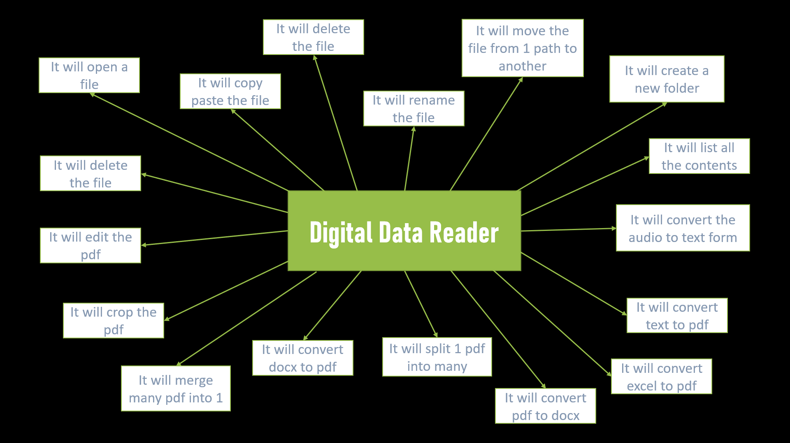

Fig 4.1: Block diagram

## 4.2 Flowchart

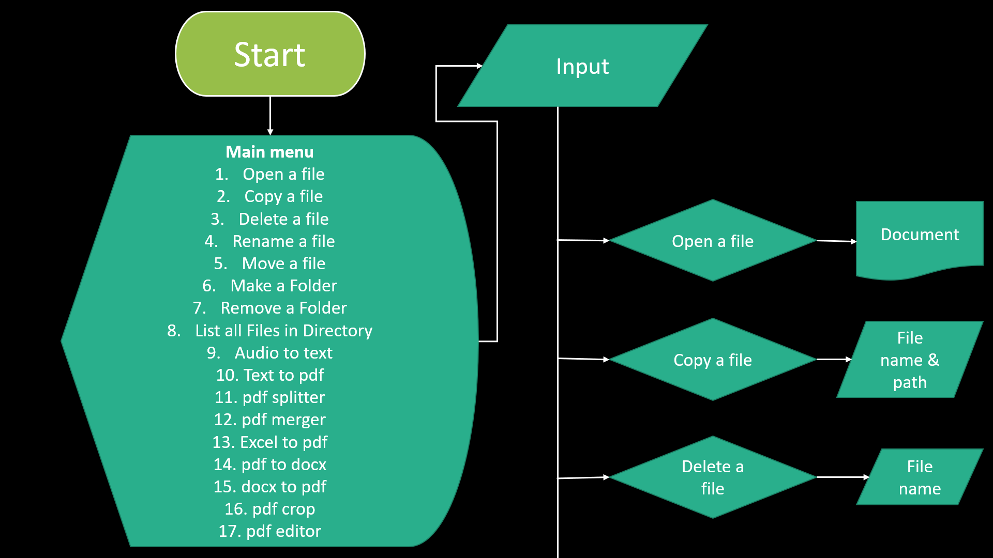

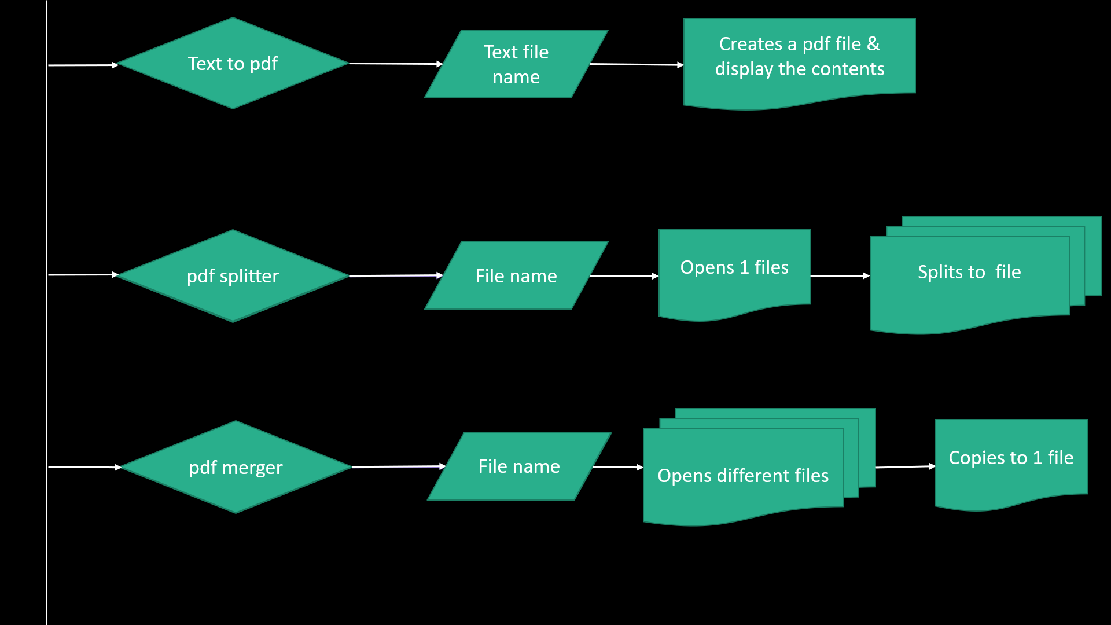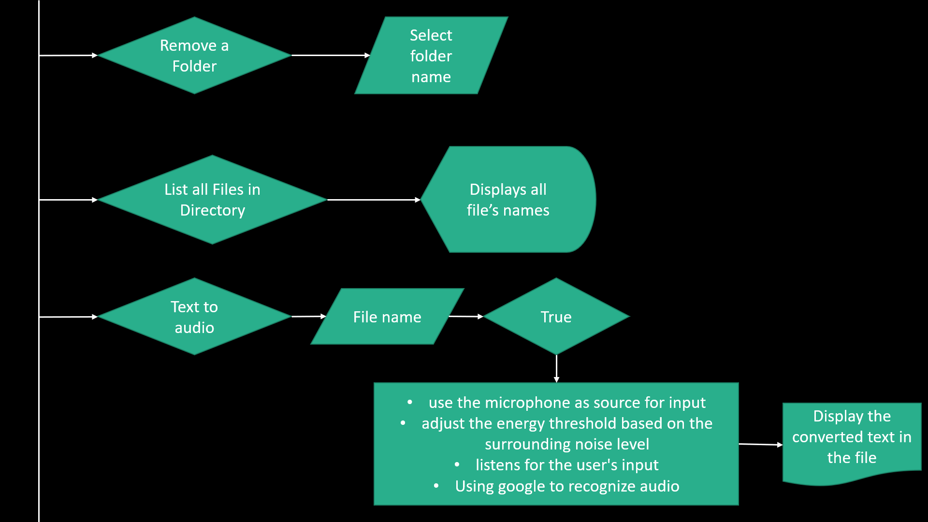

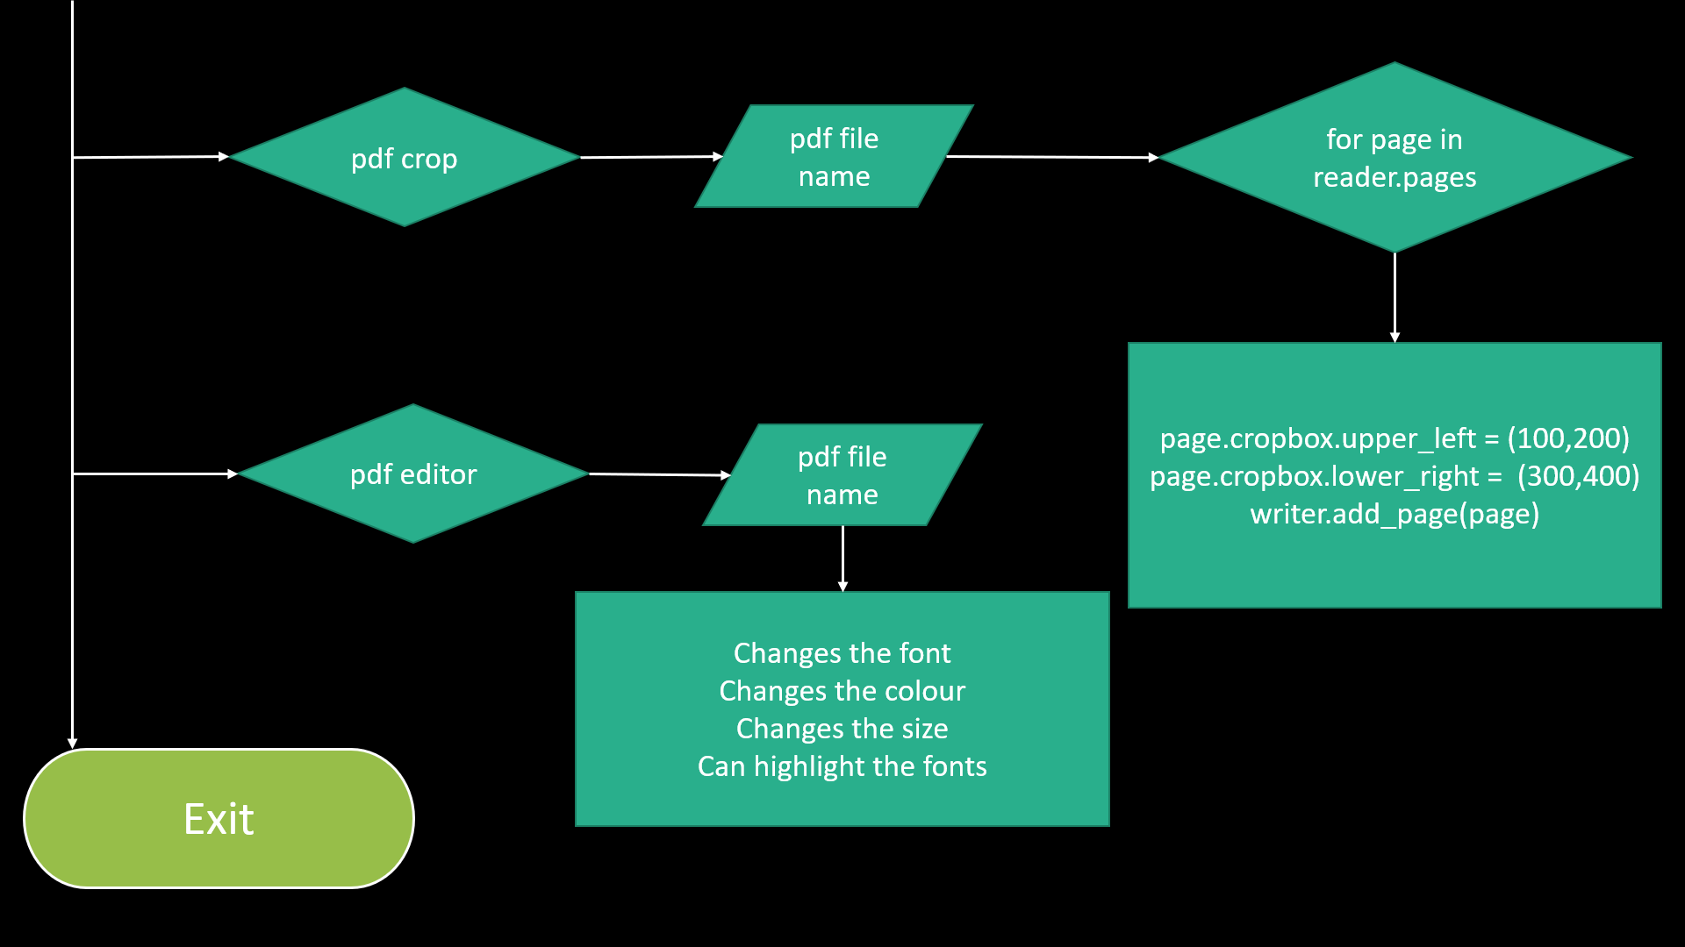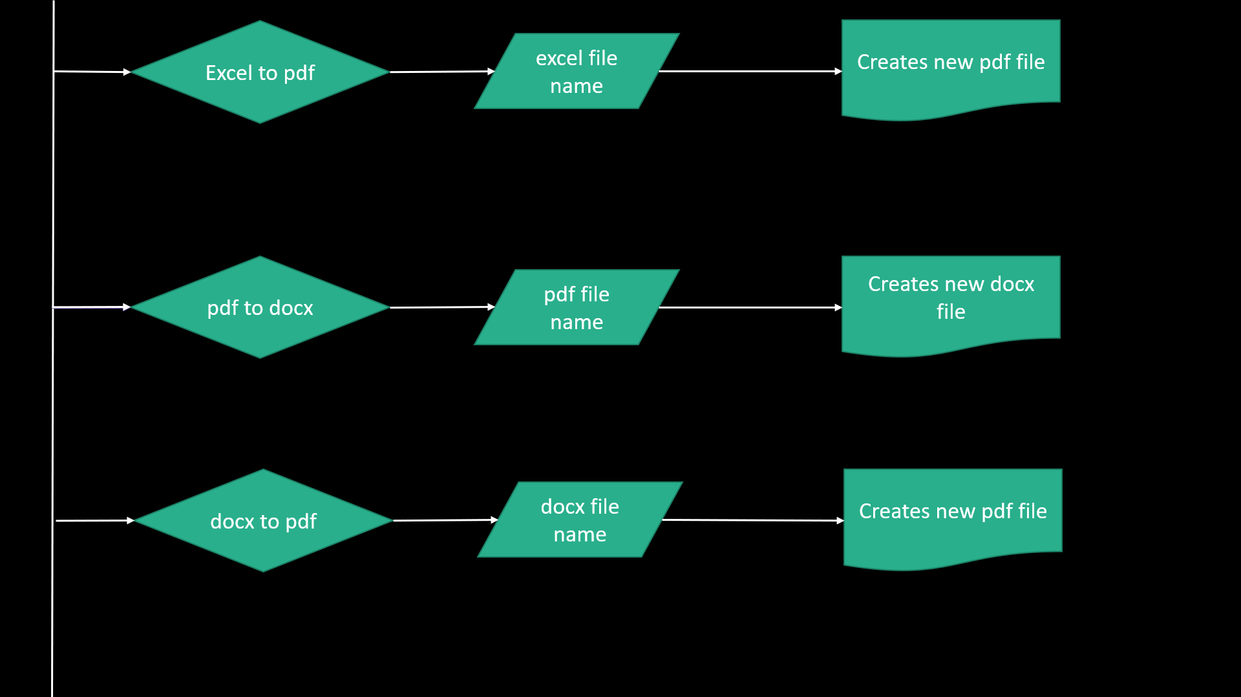

Fig 4.2: Flowchart

**4.3 Algorithm**

**1.Start**

**2.Input: Choice , File name , Voice input**

**3.Procedure: > Display the canvas/menu**

**> Check the choice**

**> Works according to the operation allocated**

**> Displays if any error/exception occur**

**4.Output: Displays the expected output**

**5.End**

CHAPTER 5

# **IMPLEMENTATION**

## 5.1 Code Implementation

We are importing the required modules for our project, they are as shown below

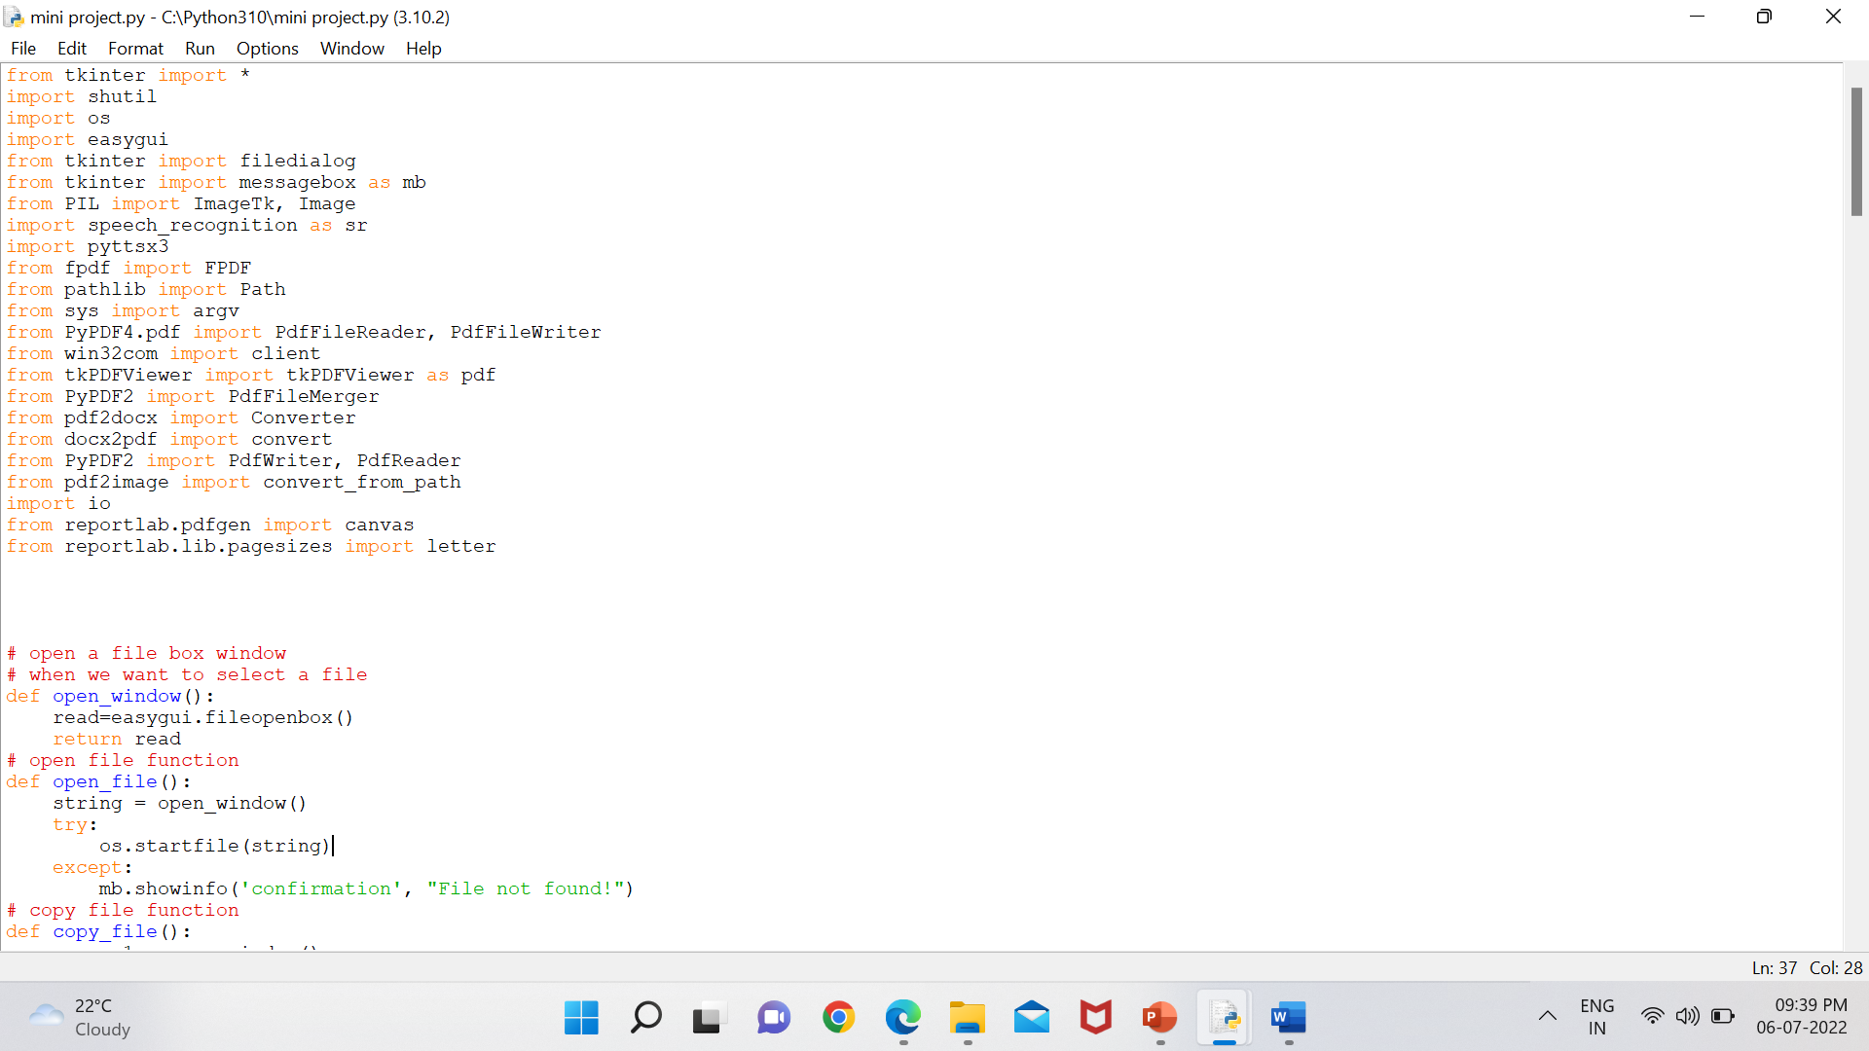

Function to open file:

Here we use easygui module and its function fileopenbox() to enable users to select the required file by selecting respective directory and return it whereever it is called.

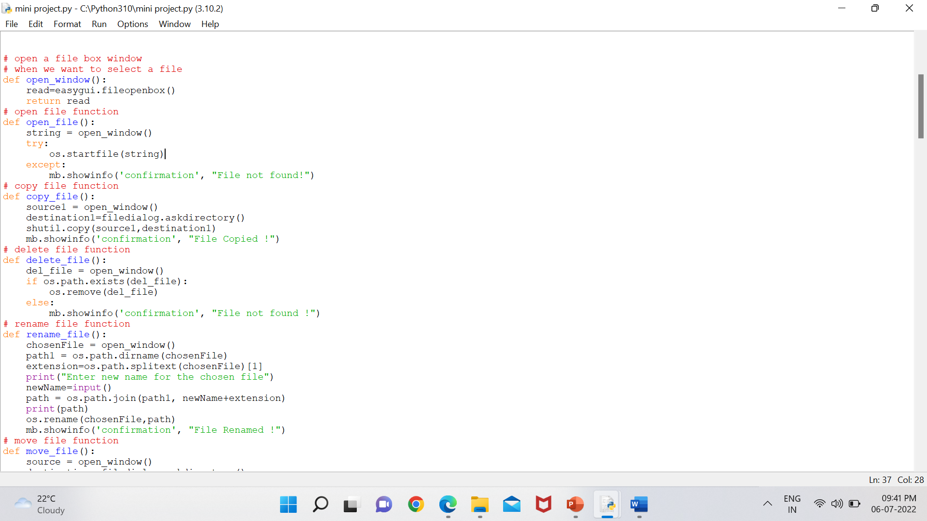

This function calls the above function to startfile function of os module

On any exception It displays an error message.



Function to copy file:

The function copies files from one directory to another. Askdirectory function of filedialog returns destination file and this instead is passed to copy function of shutil module and at last the confirmation message is shown.



Function to delete file:

The function fileopenbox is passed to remove function of os module, and thereby the file is removed and the confirmation message is displayed to the user.



Function to rename file:



Function for audio to text conversion:

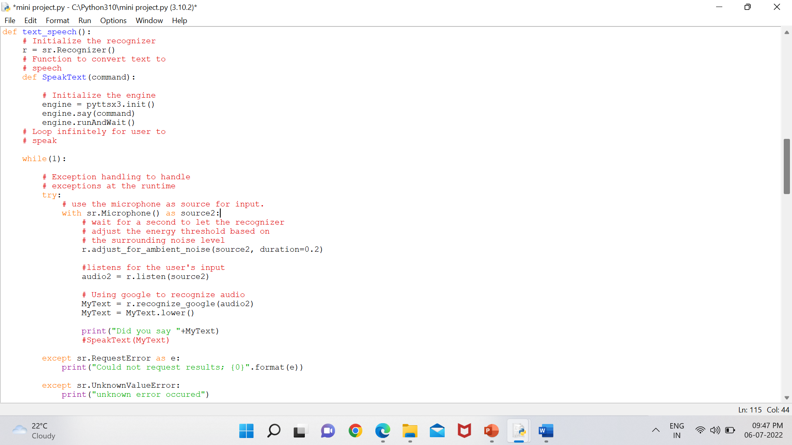

Function to convert text file to pdf format:

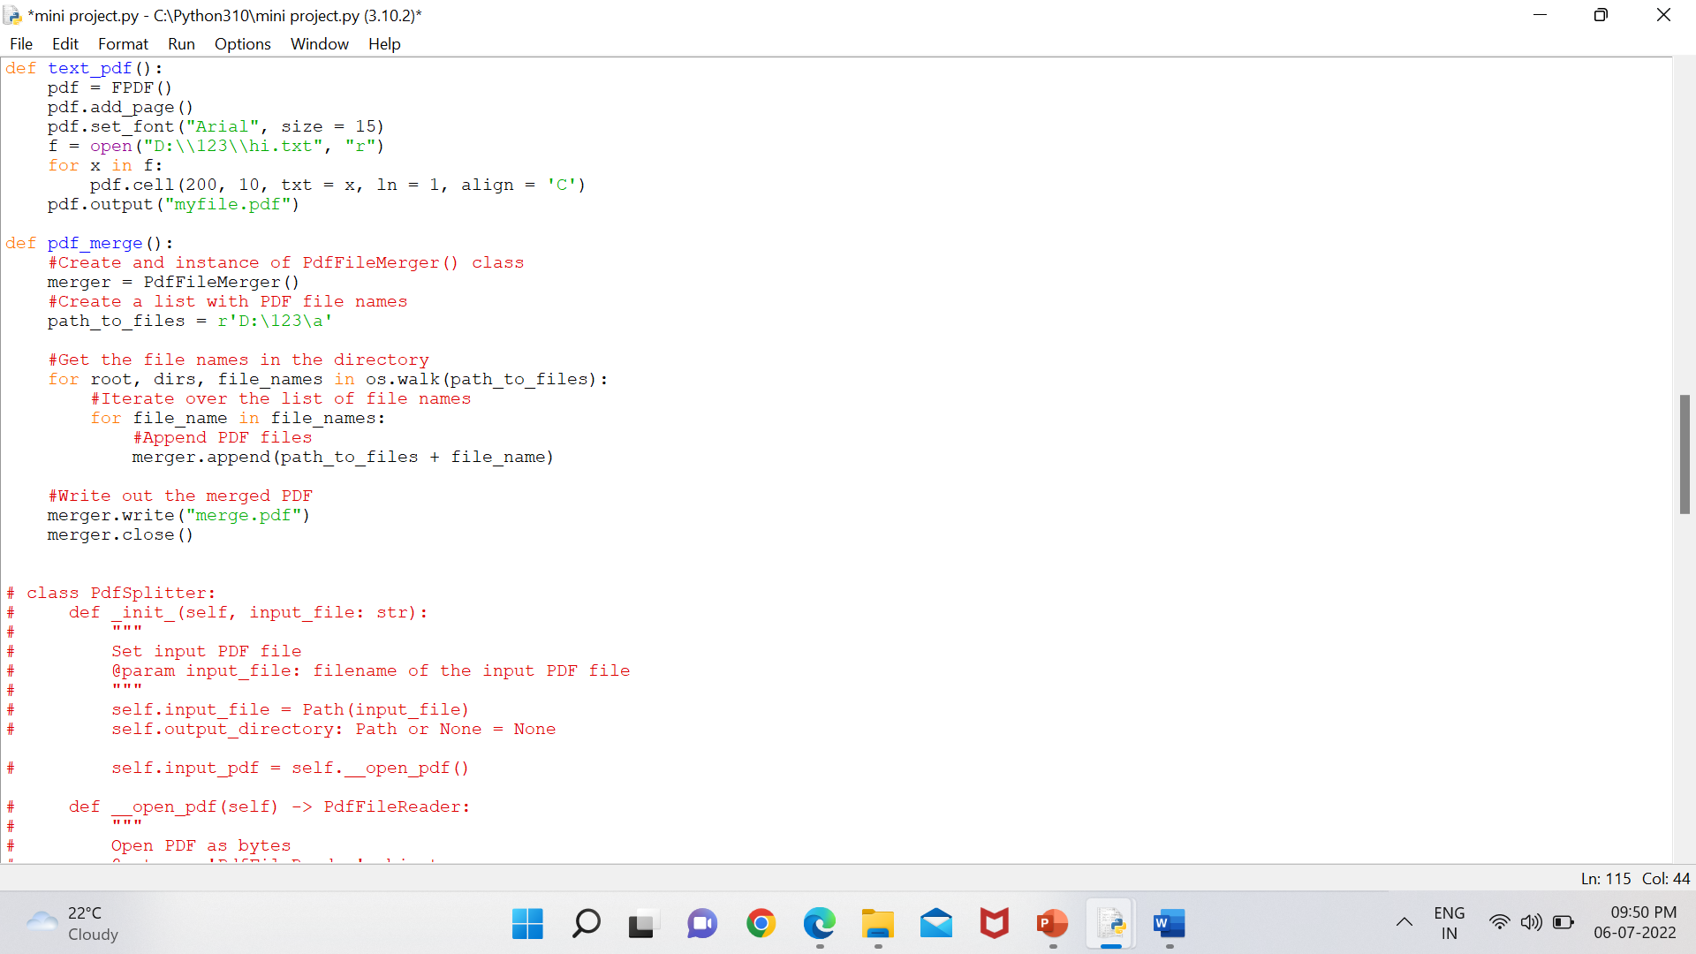

Function to merge multiple pdf’s:



Function to split pdf’s:

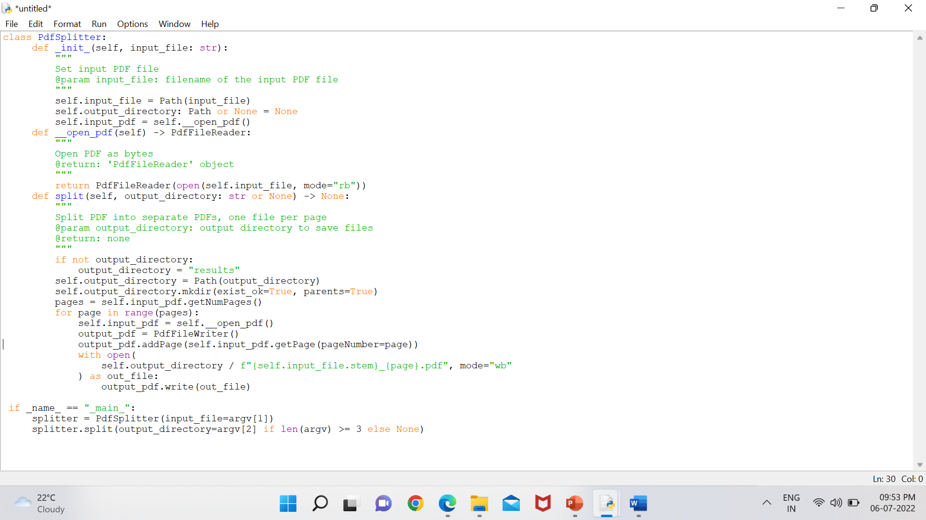

Function to View pdf’s:

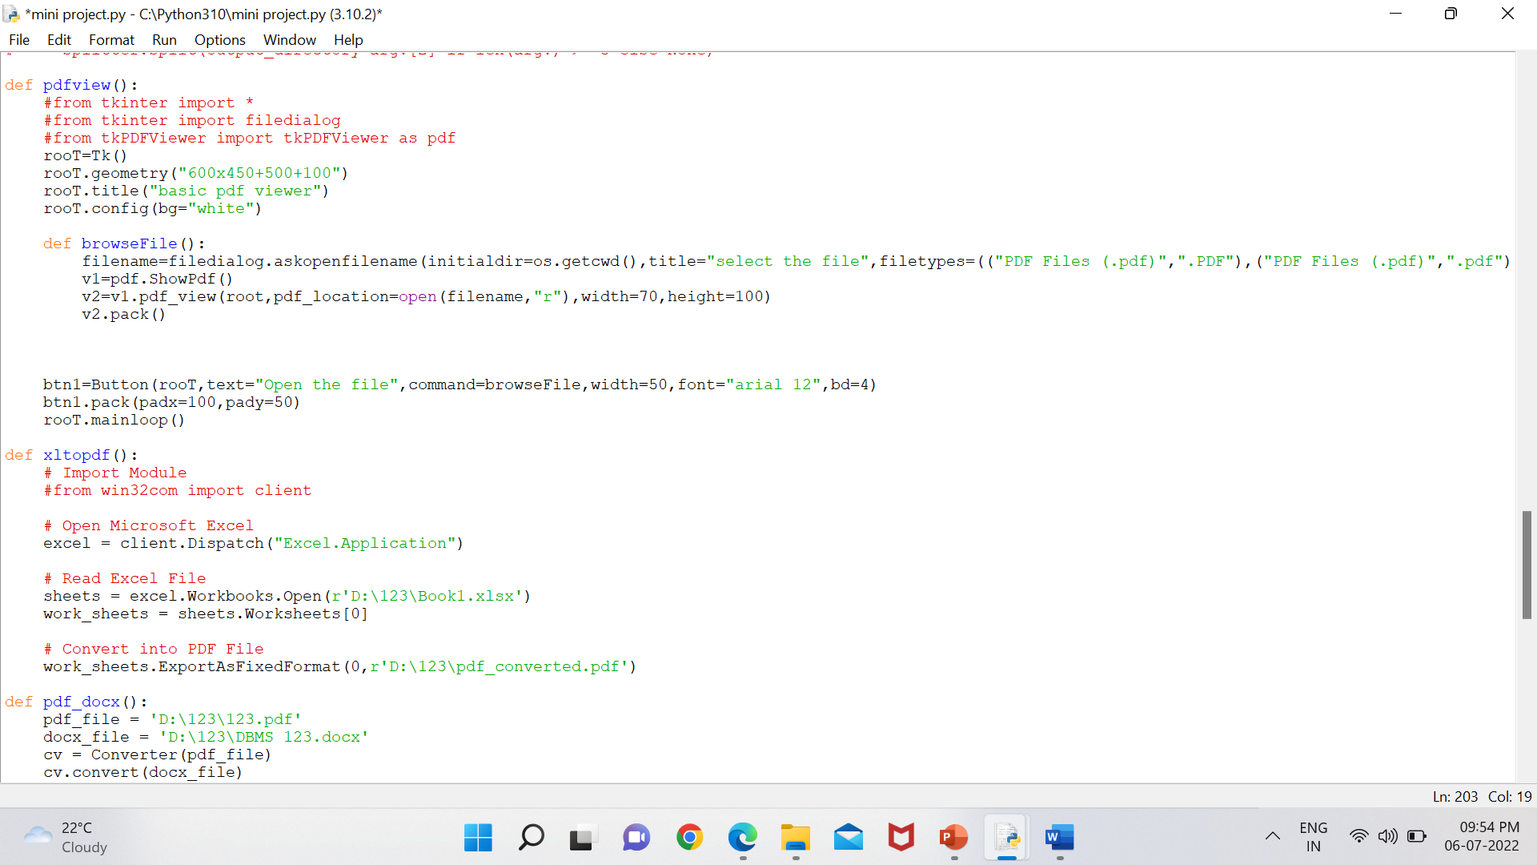

Function to convert excel to pdf:



These are functions to

* convert from document docx extension to pdf
* Crop Pdf’s
* Edit pdf’s

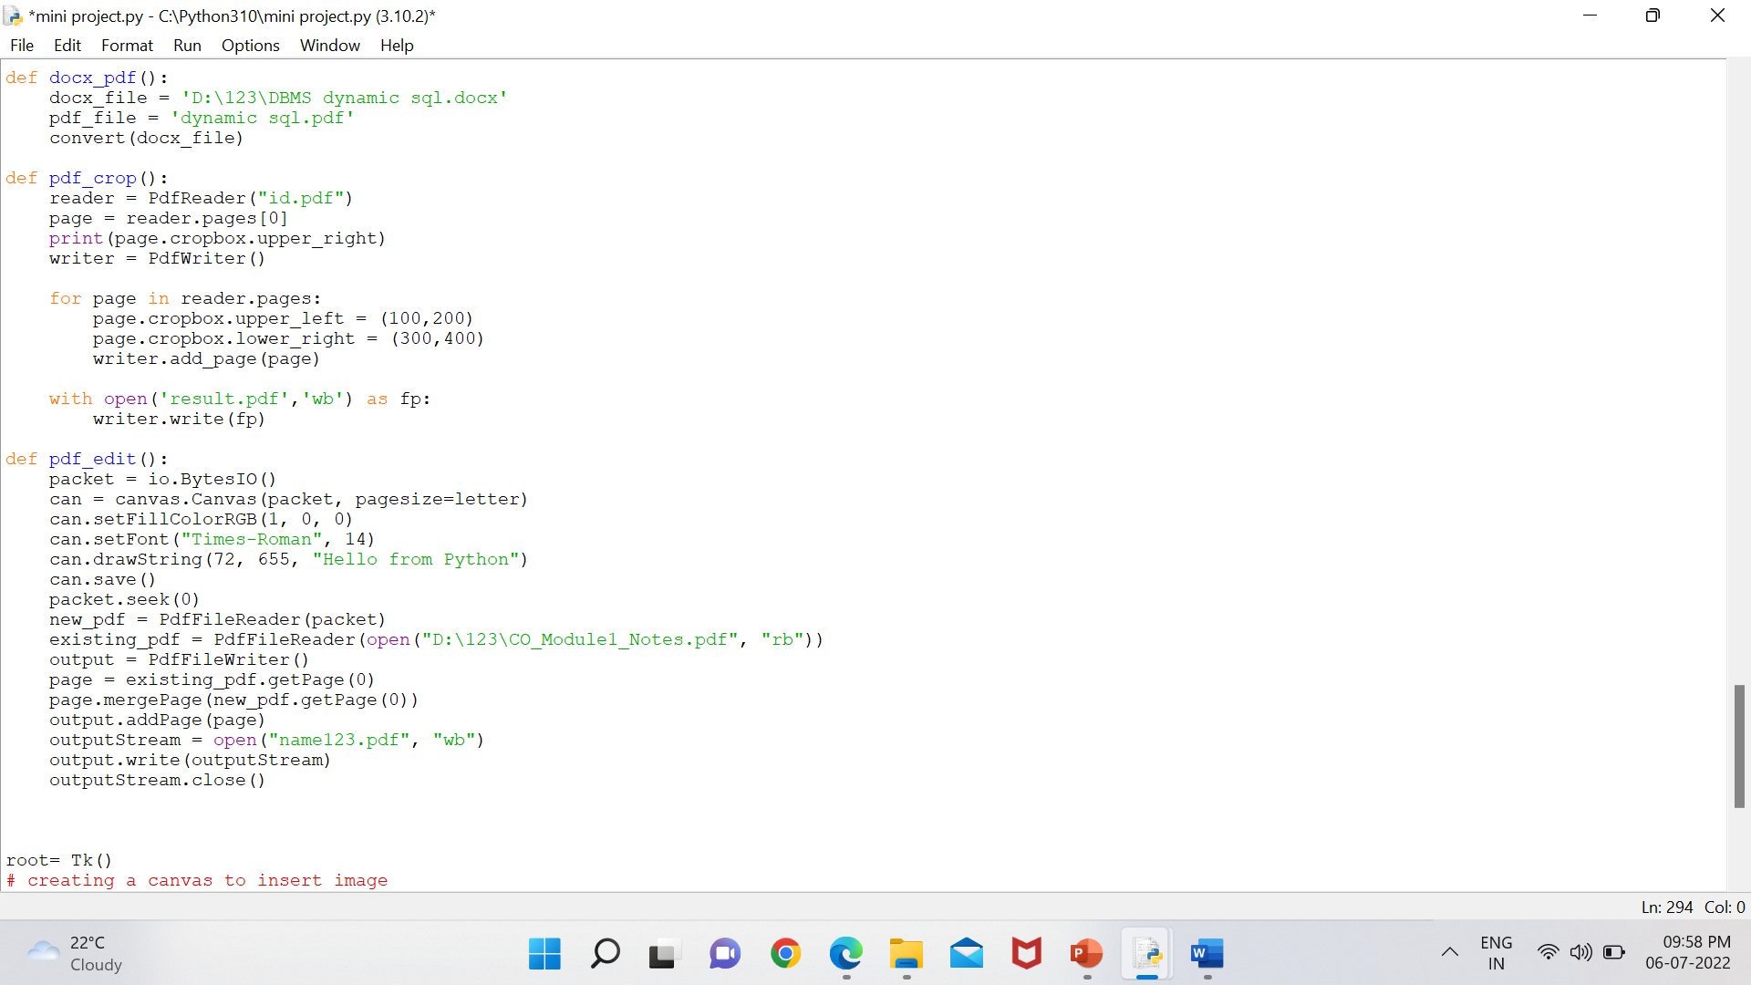

This is the graphical user interface made using tkinter.

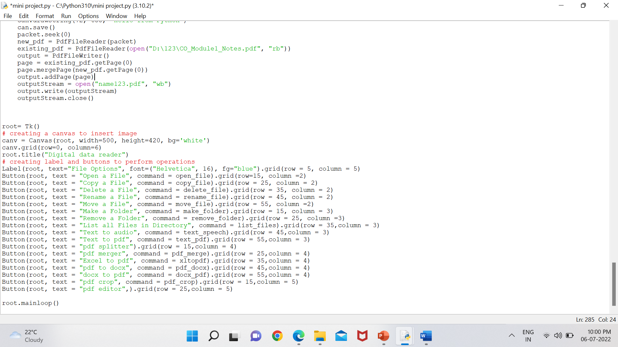

## CHAPTER 6

# **EXPERIMENTAL RESULTS**

**6.1 Output Page**

# *Digital data reader*

This is how it looks while selecting a file similar to any file manager.

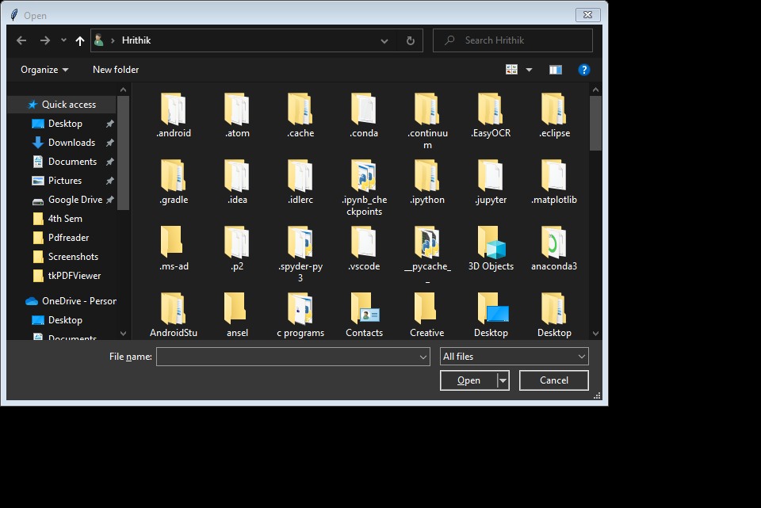

# CHAPTER 7

# **CONCLUSION AND FUTURE ENHANCEMENT**

## 7.1 Conclusion

This project is a great tool for office and can be as a great assistance to people working with files. This can not only help users save data but also helps users data to be private and secure and also avoid any data leakage to the internet and also is very much reliable.

This project has every existing feature in the market

As this works offline, there is no worry about trclackers and viruses and attacks

## 7.2 Future Enhancement

# We would like to add automated pdf to excel creation so that many data in industry can be converted to data in excel format and thereby easily used in analytics and data collection, and our project would be a great solution for this .



**DEPARTMENT OF INFORMATION SCIENCE AND ENGINEERING**

**CERTIFICATE ON PLAGIARISM CHECK**

|  |  |  |
| --- | --- | --- |
| **1** | **Name of the Student** | **Hrithik U, K L Tejas** |
| **2** | **USN** | **1NH20IS063, 1NH20IS068** |
| **3** | **Course** | **UG** |
| **4** | **Department** | **ISE** |
| **5** | **Semester** | **4th** |
| **6** | **Mini Project/Project Report /**  **Internship Report/Seminar Report/ Paper Publication/Ph.D Thesis** | **Project Report** |
| **7** | **Title of the Document** | **Digital Data Reader** |
| **8** | **Similar Content(%)identified** | **3%** |
| **9** | **Acceptable maximum limit (%) of similarity** | **30%** |
| **10** | **Date of Verification** | **04/08/2022** |
| **11** | **Checked by (Name with signature)** | **Dr. Kalaivani D** |
| **12** | **Specific remarks, if any :** | **1st  Attempt** |

We have verified the contents as summarized above and certified that the statement made above are true to the best of our knowledge and belief.

**Research coordinator**

**REFERENCES**

1. Python programming language and its community
2. Google
3. Wikipedia
4. Stackoverflow
5. python official website
6. Youtube
7. Udemy
8. Coursera